Sprawozdanie z laboratorium 1
Michal Glowacki, Szymon Mirr

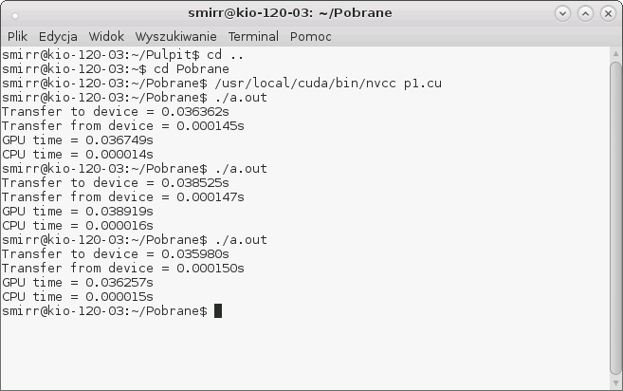
Zadanie 1
N = 1000
Transfer to device = 0.035980s
Transfer from device = 0.000150s
GPU time = 0.036257s
CPU time = 0.000015s

N = 10000
Transfer to device = 0.034956s
Transfer from device = 0.000188s
GPU time = 0.035276s
CPU time = 0.000140s

N = 100000
Transfer to device = 0.038478s
Transfer from device = 0.000480s
GPU time = 0.039134s
CPU time = 0.001499s

N = 1000000
Transfer to device = 0.040683s
Transfer from device = 0.002825s
GPU time = 0.044387s
CPU time = 0.015620s

N = 100000000
Transfer to device = 0.812811s
Transfer from device = 0.236695s
GPU time = 1.049746s
CPU time = 1.624243s

N = 150000000
Transfer to device = 1.210104s
Transfer from device = 0.350549s
GPU time = 1.560966s
CPU time = 2.419993s

CPU ma znaczna przewage nad GPU przy malej i sredniej ilosci obliczen, jednakze przy gigantycznych ilosciach obliczen (N>10000000) to GPU przejmuje prowadzenie.

Zadanie 2
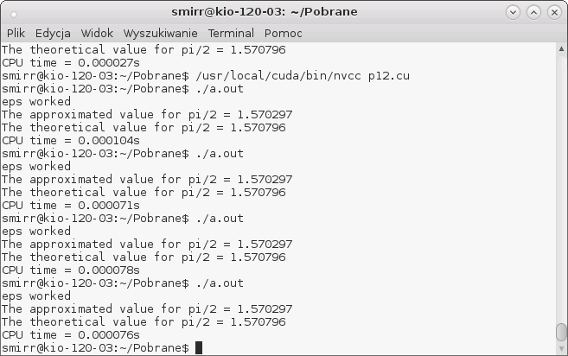
eps = 0.0005
The approximated value for pi/2 = 1.570297
The theoretical value for pi/2 = 1.570796
CPU time = 0.000076s

eps = 0.0001
The approximated value for pi/2 = 1.570696
The theoretical value for pi/2 = 1.570796
CPU time = 0.000108s

eps = 0.00001
The approximated value for pi/2 = 1.570786
The theoretical value for pi/2 = 1.570796
CPU time = 0.000388s
eps = 0.000001
The approximated value for pi/2 = 1.570795
The theoretical value for pi/2 = 1.570796
CPU time = 0.003204s

eps = 0.0000001
The approximated value for pi/2 = 1.570796
The theoretical value for pi/2 = 1.570796
CPU time = 0.035268s

Czas obliczen na CPU jest bardzo krotki.

